**Course _______Specialist______ Year __12_____**

Student name: ________________ Teacher name: ________________

Date: 17 June Weds p3 (Advo)

**Task type: Response**

**Time allowed for this task: _____45______ mins**

**Number of questions: _____7______**

**Materials required:** Calculator with CAS capability (to be provided by the student)

Standard items: Pens (blue/black preferred), pencils (including coloured), sharpener, correction fluid/tape, eraser, ruler, highlighters

Special items: Drawing instruments, templates, notes on one unfolded sheet of   
A4 paper, and up to three calculators approved for use in the WACE examinations

**Marks available: __42____ marks**

**Task weighting: _12___%**

**Formula sheet provided: Yes**

**Note: All part questions worth more than 2 marks require working to obtain full marks.**

**Q1 (3.3.5- 3.3.6) (2 & 3 = 5 marks)**

Consider a car A that has an initial position vector  km and moving with a constant velocity of  km/h.

1. Determine the position vector in 5 hours from now.

Consider a second car B that has an initial position  km and a constant velocity of  km/h.

1. Determine if the two cars collide and if they do the position vector of this point of collision and the time it occurs.

**Q2 ( 3.3.1, 3.3.3) (3 & 2 = 5 marks)**

Consider the two lines 

1. Determine the point of intersection, if any.
2. Determine to the nearest degree the acute angle between the two lines.

(Consider the plane that contains both lines)

**Q3 (3.3.8) (2, 3 & 3 = 8 marks)**

Consider a plane that contains the point  and has a normal vector .

1. Determine the vector equation of the plane.
2. Determine the point of intersection of the line  with the plane above.
3. Determine the distance of point  from the plane above.

**Q4 ( 3.3.9-3.3.10) (3 & 3 = 6 marks)**

1. Solve the following system of linear equations. Working must be shown.



Consider the constants  in the system below.



1. Determine all the value(s) of such that:
2. There will be an unique solution
3. There will be infinite solutions
4. There will be no solutions

`

Q4 cont-

**Q5 (3.3.11 – 3.3.15) (3 & 3 = 6 marks)**

Consider an object moving with acceleration  at time  seconds. The initial velocity is and initial displacement .

1. Determine the position vector at time  seconds.
2. Determine the distance travelled in the first 10 seconds. (One decimal place)

**Q6 (3.3.15) (3 & 2 = 5 marks)**

Consider an aircraft with position vector  at time  hours. At the top of a building stands an antenna with the position vector of the highest point being .

1. Determine the times the aircraft is less than 100 km from the top of the antenna.
2. Determine the closest approach of the aircraft and the time it occurs.

**Q7 (3.3.15) (4 & 3 = 7 marks)**

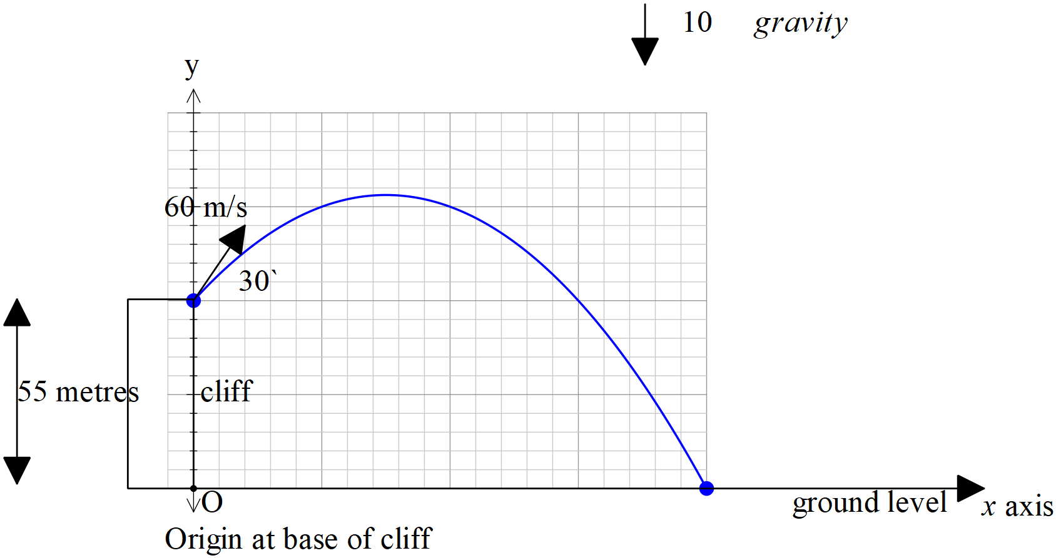

Consider a football that is kicked off the top of a cliff of height 55 metres with an initial speed of 60 m/s at an angle of  with the horizontal. The acceleration due to gravity is .

1. Show using **vector integration** how to determine the exact cartesian equation of the path using the base of the cliff as the origin.
2. Determine the time, one decimal place, taken to hit the ground and the horizontal distance of this point from the base of the cliff.

**End of test**